COMPUTER STUDIES
MARKING SCHEME
Paper 1
SECTION A (40 MARKS)
Answer ALL the questions in this section
1. State TWO characteristics of fifth generation computer (2 Marks)
a) Artificial intelligence
b) Connectivity to the internet
c) Superior hardware and software
d) Very small in size
First two correct answers @ 1 Mark each
2. a) The following number was entered by a computer user into a system 5.66894 and the first time it displayed 5.66 on the screen, he entered it again and it displayed 5.67; explain the type of errors that occurred during data processing (4 marks)
The first time it was truncation error which results from having a real number that has a long fractional part which cannot fit in the allocated memory space while the second time it was rounding error which results from raising or lowering a digit in a real number to the required number.
3. Describe any TWO elements of a computer file. (2 marks)
Character - it is the smallest element of a file and refers to a letter, number, letter or symbol that can be entered, stored and output by a computer.
Field- A single character or collection of characters that represents a single piece of data
Record – A collection of related fields that represent a single entity.
First two correct answer @ 1 mark
4. Identify the following tools associated with DTP (3 marks)
Draw Text box

Orientation
 Group
5. State three risks posed by improper cabling in a computer laboratory (3marks)
· Electric shocks to the user
· Risk of fire outbreak in the laboratory
· Risk of tripping and injuries
· Power interruption caused by stumbling on the cable
· Can cause damage to data cables
6. Study the word processor screenshot below and answer the questions that follow
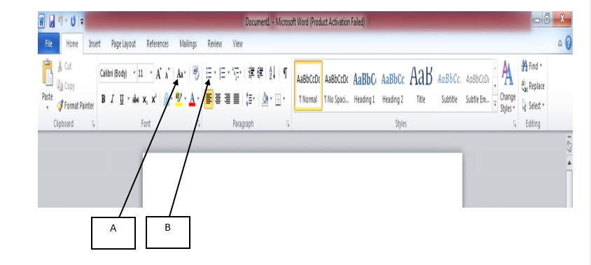
a) Give the relevance of parts labelled: (2marks)
(i) A Change case
(ii) B Bullets
b) Identify any two icons you could use as paragraph formatting tools from the diagram above (state their names) (2marks)
Text Alignment
Indent
Line spacing
Numbering
Bullets
7. List TWO ways in which computer technology can be used in law enforcement. (2 marks)
- · Databases are used to analyze forensic fingerprints
- · Criminal records can be kept in the computer database
- · Computers can be used in surveillance of the streets i.e. us of CCTv cameras
- Communication to the authorities using email/ teleconferencing
8. State two characteristics of parallel cables (2 marks)
- It is fast in transmitting data
- Has a set of 8 wires
- Covers short distances
(first 2 correct @ 1mk each)
9. File conversion, in system development, refers to modifying or changing the format of files when a new system is introduced e.g. From manual to computerized. State any three factors considered before the file conversion process. (3marks)
i. Whether the new system requires a new operating system
ii. Whether you need to create new database files for the new system e.g. manual to electronic files.
iii. Whether you need to install new application software.
(first 2 correct @ 1mk each)

​10. Differentiate between the following in relation to data security and control (4 marks)
(i) Password and Biometric Authentication.
- Password is an encoded string of characters that enables a person to be positively identified before being given access while,
- Biometric authentication relies on a unique aspect of human features like finger prints, iris or arrangement of facial features. It is one of the most secure authentication mechanisms because no two people can have the same features.
​ (ii) Privacy and Confidentiality.
- Privacy refers to an individual’s right to control access to data or information belonging to himself or herself.
- Confidentiality refers to the means of protecting private or corporate data or information from unauthorized access or disclosure.
11. Peter would like to send photos to Jennifer via e-mail. Outline the steps Peter would follow to send the photos as file attachments (3marks)
- Launch the e-mail program such as gmail, yahoomail, etc
- Click new or compose to create a new e-mail.
- Click the file attachment button.
- Locate the photos to attach and click attach.
- Click the send button.
​​(any correct sequence @ 3 marks)
12. With the increase in use of electronic communication, many different forms of communication has been introduced. Distinguish between webcasts and webinars (2 marks)
Webcasts refers to the delivery of live or delayed sound or video broadcasts over the World Wide Web.The captured sound and video is digitised and streamed on a web server while Webinars refers to conducting a seminar or lecture via the World Wide Web using graphics, text, and live voice where the audience is able to interact with the presenter by asking questions by sending instant messages. This interactive element allows the presenter and the audience to give, receive and discus information
(correct @ 2marks)
13. State three reasons why it is important to define datatypes of fields in a database correctly.
(3 marks)
- Memory use optimisation when the program is loaded;
- Assist in trapping errors during data input;
- So that appropriate computation can be performed;
- Increase speed of processing.
(first 3 @ 3 marks)
14. Explain two benefits that the employer will get by allowing workers to do the office work through telecommuting.
The working time is not limited to official working hours/office available 24 hours.
Employer saves on office space.
Does not have to pay for commuter allowance.
Employer may not require permanent employees.
Employer may outsource expert skills that are not available locally.
(First two correct @ 2 marks)
15.What is the meaning of IP address as used in networking. (1 mark)
IP address is a unique address that identifies a device on the internet or a local network

SECTION B (60 marks)
Answer question 16 and any other THREE questions from this section in the spaces provided.
16. a) State any THREE differences between an Interpreter and a Compiler (3 marks)
Compiler | Interpreter
1. It translates the entire source code into the object code equivalent | It translates the source code one statement at a time to its equivalent source code
2. Its object code is stored therefore the execution is fast | The object code is not stored, so each time an execution has to take place it has to e translated thus the execution is slower.
3. Since the object code is stored, it occupies a lot of storage space. | It does not require a lot of storage space since the object code is not stored.
b) b) State the best application area for each of the following languages. (4marks)
(i) FORTRAN
Developing engineering, architectural and mathematical solutions
(ii) BASIC
Teaching programming
(iii) OCCAM
Artificial Intelligence
(iv) PHP
Developing websites

c) Study the flowchart below and answer the questions that follow:

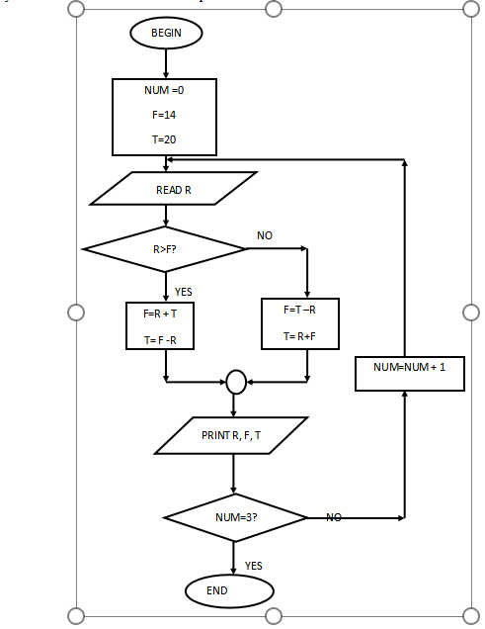

I. What would be the output if the following values were input; 40, 20, 15, 1 (2 marks)
NUM | R | F | T
0 | 40 | 14 | 20
1 | 20 | 60 | 20
2 | 15 | 0 | 20
3 | 1 | 19 | 20
Award ½ mark for each correct row max 2 marks
II. Write a pseudocode for the flowchart above (8 marks)
BEGIN
NUM = 0
F = 14
T = 20
REPEAT
READ R
IF R>F THEN
F = R +T
T = R – F
ELSE
F =T – R
T = R+ F
PRINT R, F, T
NUM = NUM + 1
UNTIL NUM = 3
END.

17(a) State three instances with reason where the use of scanners is highly preffered than keyboards as a method of data entry. (6 marks)
- In supermarkets
At the point of sale terminal (POS). OBR scanners read products faster, more accurate and efficiently compared to the keyboard
- Offices where data entry is plenty.
OCR scanner is used to convert images into text for processing
- In banks
To process cheques and confirm the originality of banking documents
- Marking of examinations
OMR scanner is used to quicken marking processes
(First 3 correct @ 2marks each)
(b) State the meaning of the phrase ‘PLUG AND PLAY’ as used with computer systems: (2 marks)
i) ‘PLUG AND PLAY’
This is a feature with the operating system that lets the computer user use a device immediately it has been plugged. ​meaning that the user does not have to manually install drivers for the device or even tell the computer that a new device has been added.
(correct @ 2 marks)
​c) List an input device appropriate for each of the following tasks: (3 marks)
I) A Biology Teacher wants to upload a picture of a new plant species into her laptop;
- ocr scanner, camera
ii) A construction engineer wants to upload her hard copy house plan into the computer;
- ocr scanner
iii) A musician wants to record his audio music into the computer;
​ - microphone (correct @ 1 mark each)
d) State any two application areas of USB cables which makes them more popular than other cables. (2 marks)
- Charging of microcomputers such as palmtops
- Support almost all peripheral devices
- Used as a data cable that transport data across small devices
(first two correct @ 1 mark each)
e)LIST ANY TWO TASKS THAT AN ELECTRONIC SPREADSHEET SHOULD BE ABLE TO PERFORM OTHER THAN CALCULATIONS.
Production of graphs
Automatic recalculation
Projection of growth curves through what-if analysis
Have editing and formatting features that can be used to change appearance of data and make necessary changes.
Have features of a database therefore they can be used to filter, sort, validate data and remove duplicates.
They can import and export data from other programs and platforms.

18. (a) Convert the following numbers to Decimal number system
(i) 010011.10001₂ (3marks)
ANS 19.53125
(ii) 36.5₈ (3marks)
ANS 100100.1₂
(b) Evaluate 1010₂+1010₂+1001₂+00010₂-1101₂ (3marks)
ANS 1001₂
(c) Using two complements, show how the arithmetic below would be carried on an 8-bit computer system by
subtracting 40₁₀ from 50₁₀ , write your answer in decimal notation. (4marks)
ANS 00001010₂
(d) Describe two reasons for the use of Octal and Hexadecimal number system (2marks)
- they align neatly with binary and simplify operations.
-It reduces the length of binary numbers significantly, making them easier to write, read, and debug.
19. (a) Name three Data Terminal Equipment used in a computer network (3marks)
• Computer (PC or Laptop)
- Acts as a source or destination of data in a network.
• Router (when configured as an endpoint)
- Functions as DTE when it interfaces with a Data Communication Equipment (like a modem) for WAN connectivity.
• Printer (Network Printer)
- Receives data for output directly from other DTEs like computers over the network.
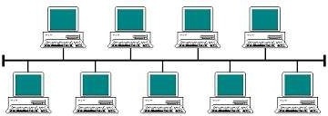
(b) Use the diagram to answer the questions that follow
A
(i) Identify the topology represented in the above diagram (1mark)
- Bus topology
(ii) State the function of the part marked A (2marks)
-terminator
(iii) Name two limitation of this technology (2marks)
- Network Failure from Main Cable Issues
  - If the main cable (backbone) fails or gets damaged, the entire network goes down, since all devices depend on that single line for communication.
- Difficult Troubleshooting and Maintenance
  - It can be hard to identify faults, and as the network grows, performance decreases due to data collisions and signal degradation.
(c) Name four roles of a Network Administrator (4marks)
- Network Setup and Configuration
- Monitoring Network Performance
- Troubleshooting and Support
- Network Security Management
- User Account and Access Control
- Backup and Recovery Planning
- Updating and Maintaining Network Systems
(d) Describe three main pathways in a computer in which components like ALU, Control unit,
Register, Buffer Cache, Main memory use to transfer data and instruction between them (3marks)
1. Data Bus
- Purpose: Transfers actual data between components.
- Used By: ALU, Registers, Main Memory, Cache, etc.
- Example: When the CPU reads data from memory, the data travels through the data bus to the register or ALU.
2. Address Bus
- Purpose: Carries the address (location) of where data should be read from or written to.
- Used By: CPU, Memory, Cache.
- Example: The Control Unit sends an address through the address bus to fetch data from a specific memory location.
3. Control Bus
- Purpose: Carries control signals and commands (e.g., Read, Write, Interrupt).
- Used By: Control Unit to coordinate actions between CPU and other parts.
- Example: The Control Unit sends a Read signal via the control bus to tell memory to send data to the CPU.
20. Use the database tables below to answer the questions that follow.

CUSTOMERS TABLE
CUSTOMER NUMBER | NAME | TEL NO
9001 | Jane | 021142123
9002 | Mike | 023545532
9003 | James | 021462112
9004 | Collins | 058421123
9005 | Joseph | 032445512
9006 | Ann | 050112231

ORDERS TABLE
ORDER ID | CUST NO | DATE | AMOUNT
352 | 9001 | 2/5/2023 | 20000
235 | 9002 | 6/4/2023 | 35000
532 | 9003 | 8/6/2023 | 11000
623 | 9004 | 9/6/2023 | 65000
521 | 9005 | 23/6/2023 | 25000
231 | 9006 | 30/6/2023 | 5000

- State the most appropriate data types for each of the following fields (3 mks)
- CUSTOMER NUMBER…number
- NAME……………text
- TELNO……………number
- ORDER ID…………number
- DATE………………date/time
- AMOUNT………currency
- Determine the most appropriate primary key for each of the above tables. (2 mks) c
Customer table -Customer number
Orders table -Order ID
- List TWO fields that can be used to create a relationship between the two tables. (1mk)
CUSTOMER NUMBER
CUST NO
- Identify the foreign key in the above database tables. (1 mk)
CUST NO
- During system implementation the management of Spring Supermarket decided to run both the old system and the new system concurrently for sometime.
- Give the name of the changeover strategy that was used by the management of
Spring Supermaket. (1 mk)
PARALLEL
(ii) State any TWO disadvantages of the above changeover strategy. (2mks)

High Operational Cost
- Running both the old and new systems at the same time requires extra resources, such as hardware, software licenses, and staffing, which increases overall costs.
Increased Workload
- Staff must enter and process data in both systems, leading to double work, fatigue, and potential for errors or inconsistencies.
User Confusion
- Switching between two systems can confuse users, especially if the systems have different interfaces or processes.
Longer Transition Time
- Because both systems are used until the new one is fully proven, the changeover takes longer, delaying full adoption of the new system.

- Other than changover, list any other TWO activities performed during system
implementation. (2mks)
training of users
file conversion
- Explain TWO circumstances that may lead to development of a new information
system (2 mks)
Problem of the Existing System
- If the current system is slow, outdated, or produces frequent errors, it may no longer meet the needs of the organization.

Technological Advancements

New and improved technologies may become available that offer better performance, security, or integration.

(f) Describe the term system entropy (1 mk)
System entropy refers to the natural tendency of a system to move toward disorder or breakdown over time if not properly maintained or managed.

